Please return to the front office by day, date
Teacher Survey About Walking and Biking to School

Dear teacher,
In an effort to promote daily physical activity and reduce traffic around the school, __school name__ will be partnering with Living Streets Alliance this year to encourage walking and biking as a fun and healthy way to commute to school. We hope to develop Safe Routes to School (SRTS) projects that best meet the needs of teachers and students. Thank you in advance for your input and ideas!

1. What grade/subject do you teach? _____________

2. In your opinion, what are the attitudes of your students and parents towards walking/biking?
Students: ______________________________________________________________
Parents: _____________________________________________________________________

3. How do you normally commute to/from school (check all that apply)?
☐ Walk ☐ Bike ☐ Personal Vehicle ☐ Transit (city bus)
☐ Carpool (you and other school staff) ☐ Other: _______________

4. Would you like to walk or bike to school? Yes / No Comment(s):______________________

5. Do you have suggestions for increasing the appeal and/or safety of walking and biking to your school?
________________________________________________________________________
________________________________________________________________________

Share your interest with us!
If you’d like to stay in the loop about walk/bike activities at the school this year, please provide your contact information below. You can also follow us on facebook at www.facebook.com/SRTSTucson

Yes, I want to be informed about walk/bike projects at school name this year.

Name: ___________________ Email: _______________________ Phone: _____________

􀂅 Check here if you have interest in in-class pedestrian safety lessons.
􀂅 Check here if you’d like to encourage walking/biking by helping plan or run a SRTS activity/event.

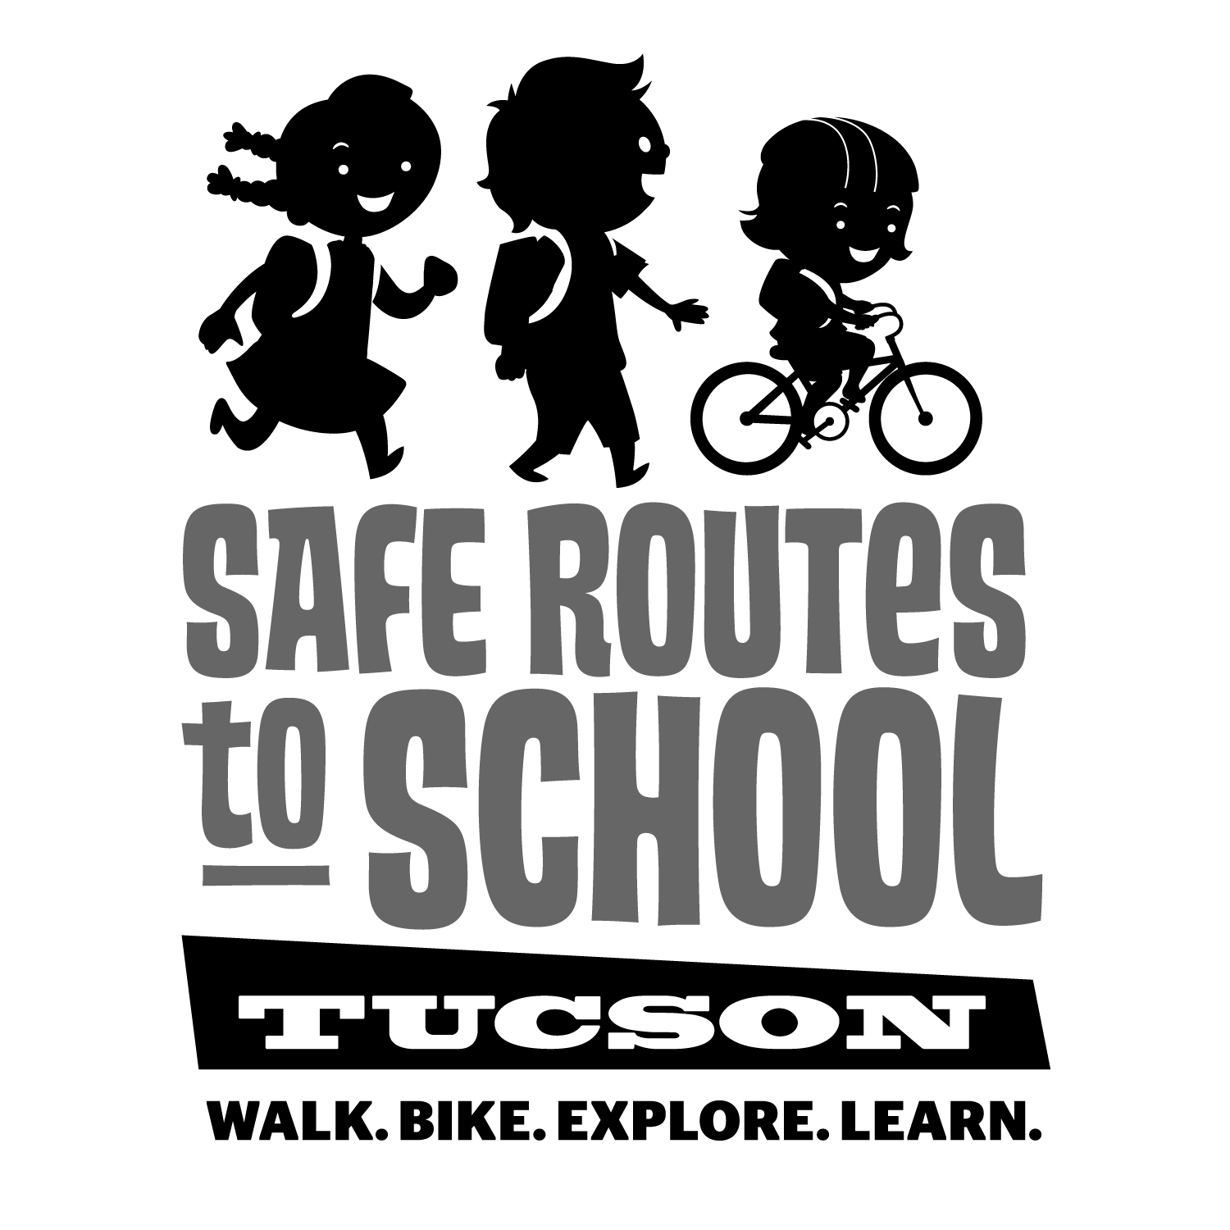
We have resources for you!
Check out the SRTS website for bicycle- and pedestrian-focused lesson plans for teaching core subjects at different grade levels. They’re ready-made for the classroom.
http://www.saferoutestucson.org/resources/

These events/activities are already on the school’s fall calendar – Add them to yours!
- Aug. 25 – SRTS at school’s open house
- Sept. 1 – “Make Tracks” Active Travel Challenge begins
- Oct. 20 – Afterschool bike repair clinic
- Oct. 26-30 – WALKtober Walk to School Challenge

